20th Annual Step Up For The Arc Walk
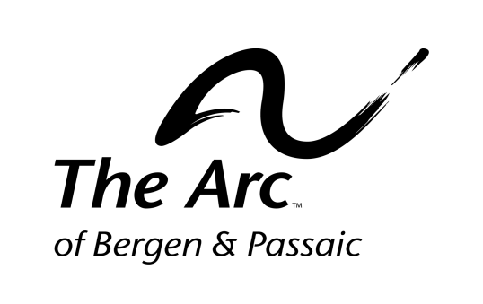
June 4, 2017
Sponsorship Form

Company Name Address City State Zip code

Contact Person Phone Number Email

Event and Platinum Sponsors may provide a display or distribute promotion product items.
*Sponsors with sponsorships at the $500-$5,000 levels will receive a 30” x 24 “sign.
*Sponsors with a sponsorship at the $250 level will receive a 30” x 12” sign.
*All sponsors responding before May 4, 2017 will be listed on the T-Shirt for the walk.
Which sponsorship opportunity are you interested in?
Event Sponsor -$5,000 Starting Line Sponsor-$750
Platinum Sponsor-$2,500 Finish Line Sponsor-$750
Premier Sponsor-$1,500 Team Photo Sponsor-$500
Children’s Activity Sponsor-$1,000 Certificate Sponsor-$500
Entertainment Sponsor-$1,000 Shuttle Sponsor-$500
Food & Beverage Sponsor-$750 Route Sponsor-$250
Balloon Sponsor-$250
We are not able to be a sponsor, but would like to make a tax-deductible donation of $

Payment Options: □ Check □ Credit Card □ Visa □ MasterCard
Account Number Expiration Date: Amount Signature Date
_________________ _____________ _________ ______________________ ___________
Please return completed form with payment to:
Development Office, The Arc of Bergen & Passaic Counties
223 Moore Street, Hackensack, NJ 07601
Questions? Please call Shirley Williams at 201-343-0322 ext. 2233

* Deadlines: T-Shirt- 05/04/2017. Signage -05/20/2017

